
Company
Logotype

Cone Beam Computed Tomography- Report



Porur Dental X-rays & CBCT

Patient Name : Mrs. Suganya Kumaravel | Date of Report : 23.06.2024
Age/ Gender : 38 years/ Female | Region of Interest : CBCT Full Skull
Referring doctor: Dr. Gopinath | Indication : Implant assessment
Clinical Notes: Nil
PATIENT INFORMATION

CBCT- Full skull provided
CBCT – IMAGE DETAILS

RADIOGRAPHIC INTERPRETATION

- Completely missing crown and root in relation to 36, 46.
- Partial loss of crown structure in relation to 26.
- The alveolar bone in relation to 36 and 46 is present with normal trabecular pattern.
- Comple hyperdense opacification of the left maxillary sinus is evident.

IMPLANT ASSESSMENT

 | 36 region | 46 region
Sub-Crestal (in mm) | 6 | 7.5
Mid- Crestal (in mm) | 9 | 8.8
Distance between alveolar ridge and the inferior alveolar nerve canal (in mm) | 14.4 | 13.2
Distance between the alveolar ridge and lower border of mandible (in mm) | 21.6 | 22.2

RADIOGRAPHIC IMPRESSION

- Partially edentulous mandibular arch.
- Fractured crown: 26.
- Left maxillary sinusitis.

Kindly correlate with clinical findings


IMAGES FOR REFERENCE

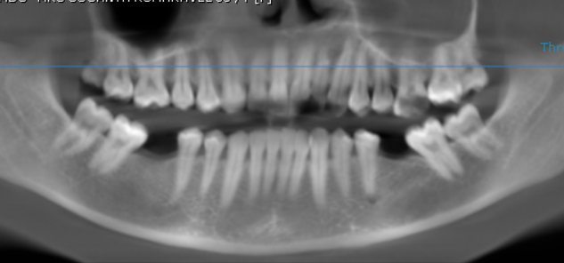
RECONSTRUCTED PANORAMIC VIEW

CORONAL VIEW
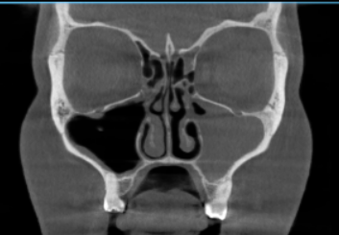

Complete opacification of the left maxillary sinus

3-DIMENSIONAL VIEW

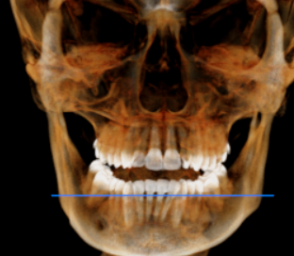

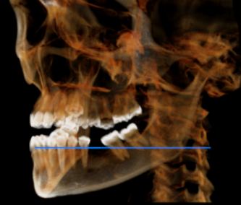
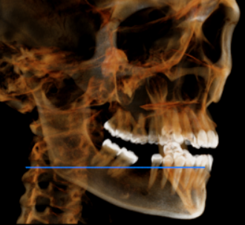

CROSS SECTIONAL VIEW

36 region | 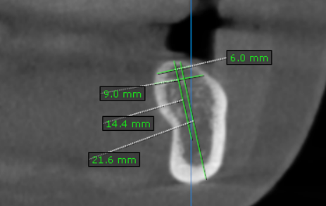
46 region | 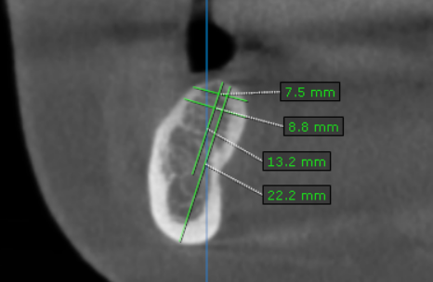

**** End of report ****

